S-HIS Flight Summary: 19-20 September 2013

D. Tobin, J. Gero, R. Kuehn, University of Wisconsin–Madison, SSEC

Summary
The Global Hawk flew a lawnmower pattern in the Gulf of Mexico to make observations of Pouch 37/Invest 95. This system was characterized by minimal organization despite very warm SSTs, high TPW, and low to moderate shear, and is somewhat similar to TS Ingrid a ~week earlier. Model forecasts at the time of take-off varied in regard to track (most taking NW into Mexico, some back east and staying in the GOM) and intensity (72 hr forecast at 1800 UTC 9/19 ranging from 10 to 60 kts). [Capital Weather Gang]: If it intensifies into a tropical storm, it would be the 10th named storm of the season (Jerry) and the 5th Atlantic tropical cyclone to affect the Bay of Campeche this season (previously we had Barry, Fernand, TD8, and Ingrid. But for now, it is meandering in the western Gulf in the same vicinity where Ingrid just made landfall and dumped a lot of rain. Moisture associated with this should also provide a good chance of very heavy rain over the northern Gulf coast and into Florida in following days.
The S-HIS operated nominally throughout the flight. The Stirling cooler was slow to get to normal operating current after startup, but detector temperature remained stable around 77 K for the duration of the mission. CPL and AVAPS also appear to have performed nominally, with 88 dropsonde profiles collected, which is a new AVAPS / Global Hawk record.

Timeline (All times are UTC and are only approximate):
- 20130919T0950 GH engine start
- 20130919T1206 SHIS Power on
- 20130919T1210 Takeoff
- 20130920T0941 S-HIS descent heaters on
- 20130920T1007 Instrument power OFF before descent (IL42, IL41, DC41, DC42)
- 20130920T1021 Instrument power ON (DC41, DC42, IL41, IL42)
- 20130920T1038 Instrument power OFF (IL42, IL41, DC41, DC42)
- 20130920T1053 Landing

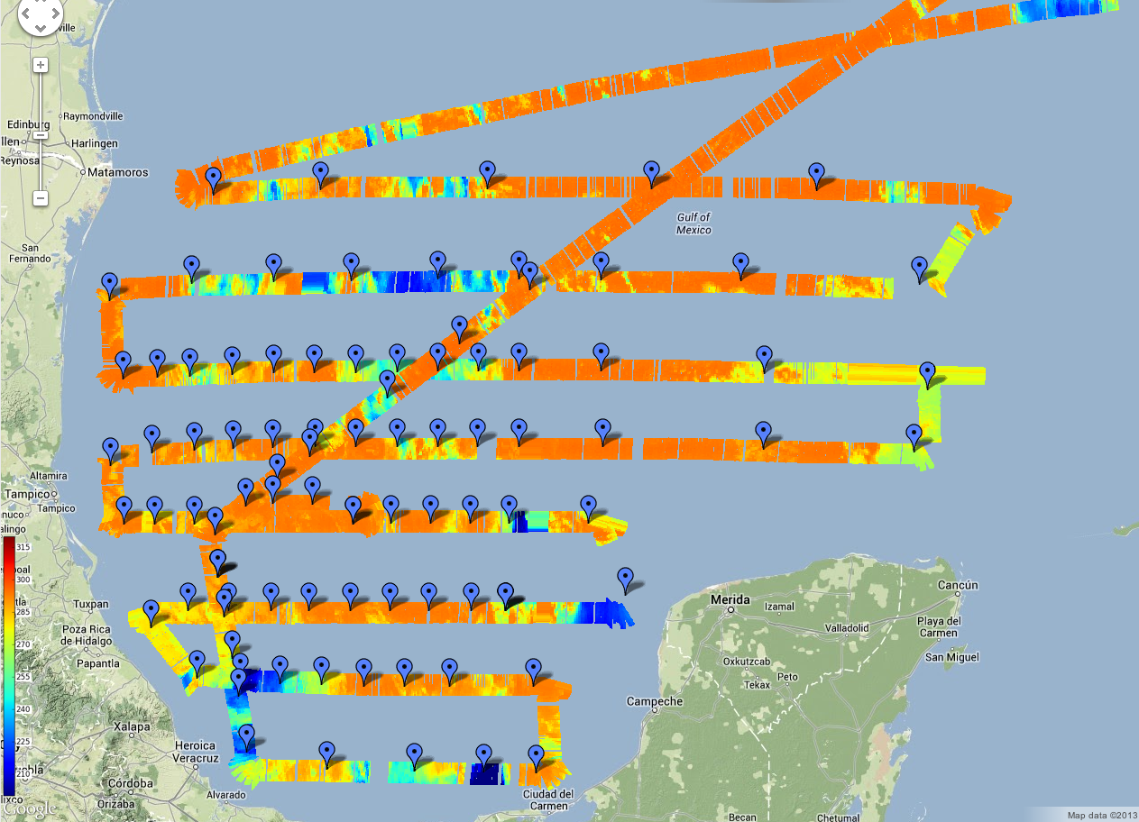
Figure 1. Scanning-HIS real-time longwave window brightness temperature observations and dropsonde locations (blue markers).
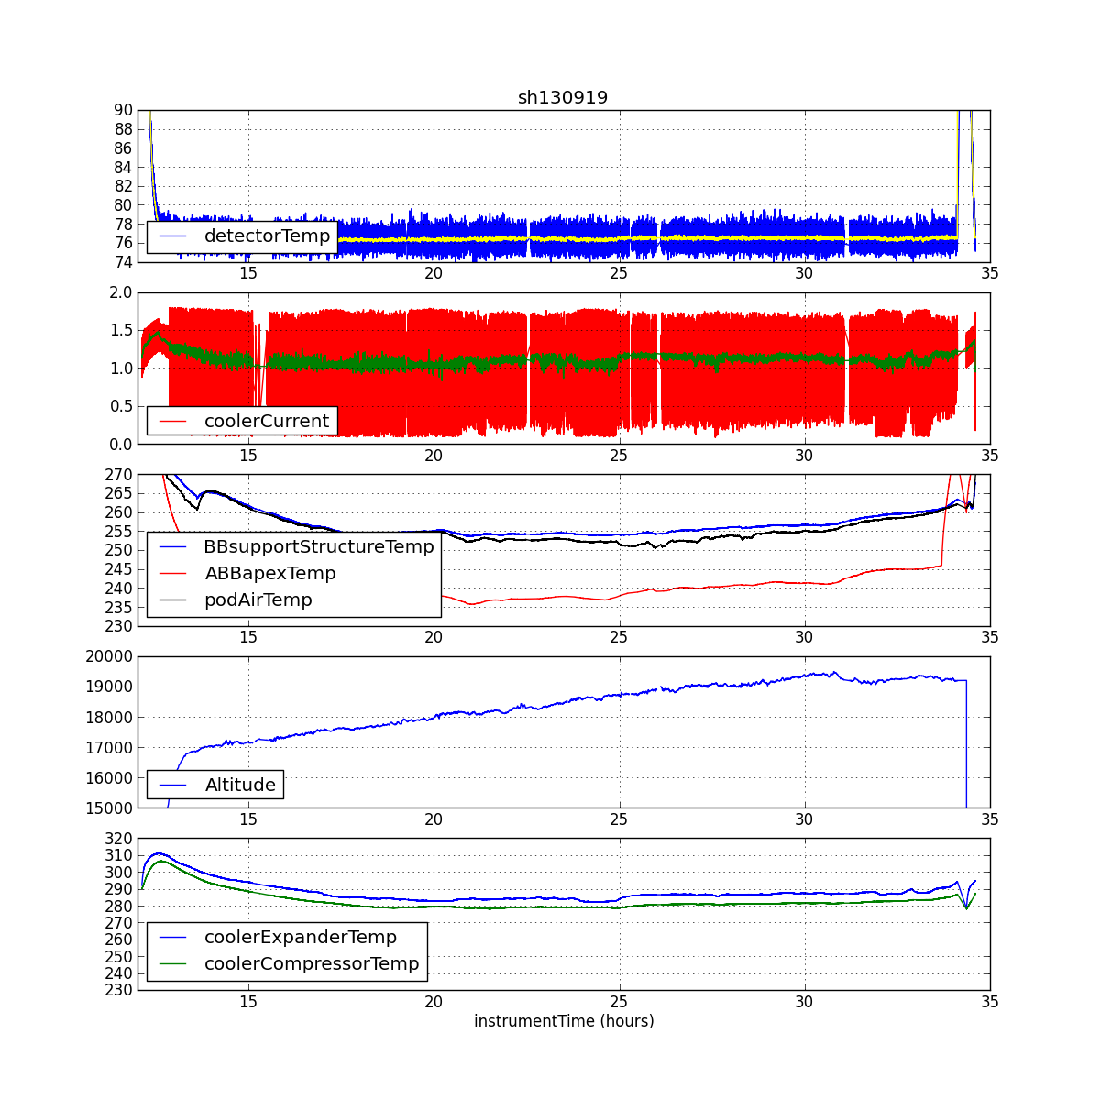
Figure 2. Time series of various Scanning-HIS engineering parameters. The detector temperature was stable at around 77 K throughout the flight. Detector current was elevated at startup but returned to its nominal 1 Amp value for the remainder of the science flight.

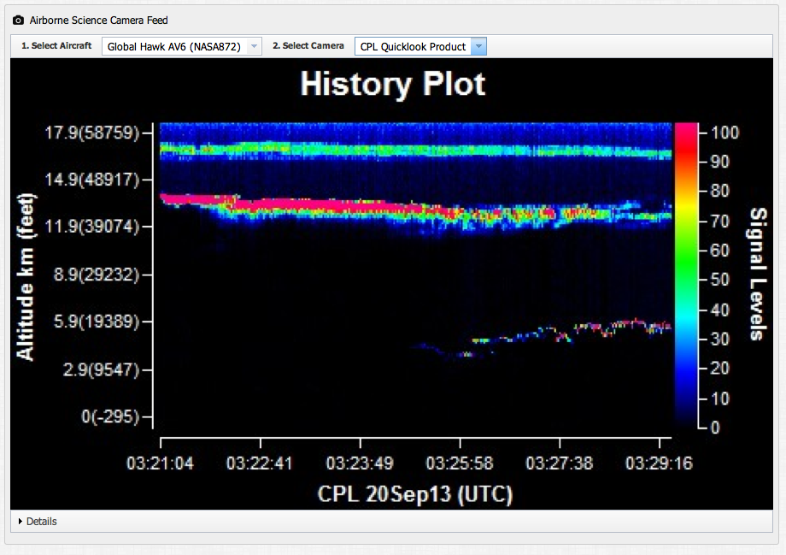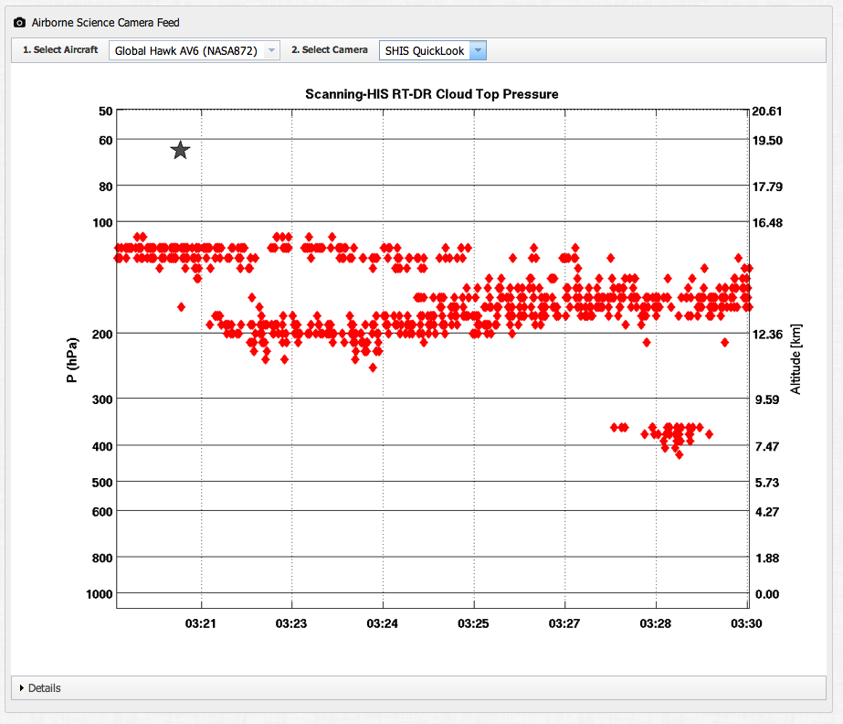
Figure 3. In the southern-most legs of the flight plan, the CPL often saw very high thin cirrus at ~16.5 km. Here is a sample comparison of the real-time CPL signal and the real-time SHIS cloud top retrievals, where the SHIS retirevals do not pick up the highest cloud layer but show good correspondence with CPL for two lower cloud layers at ~13 and 6-8 km.
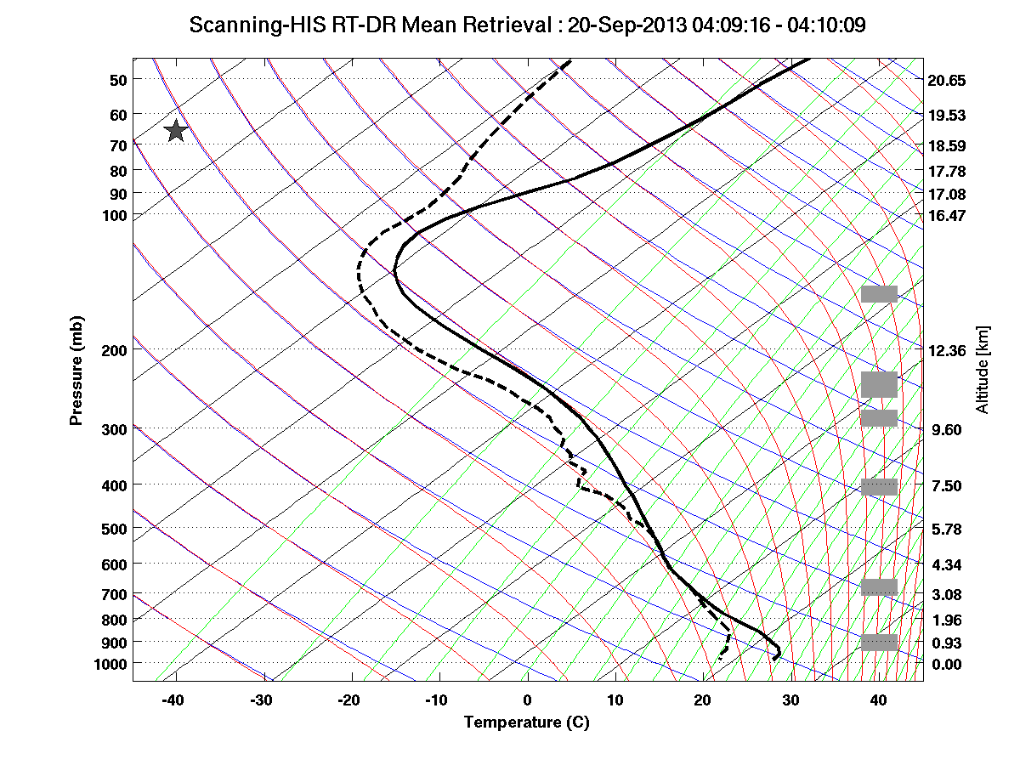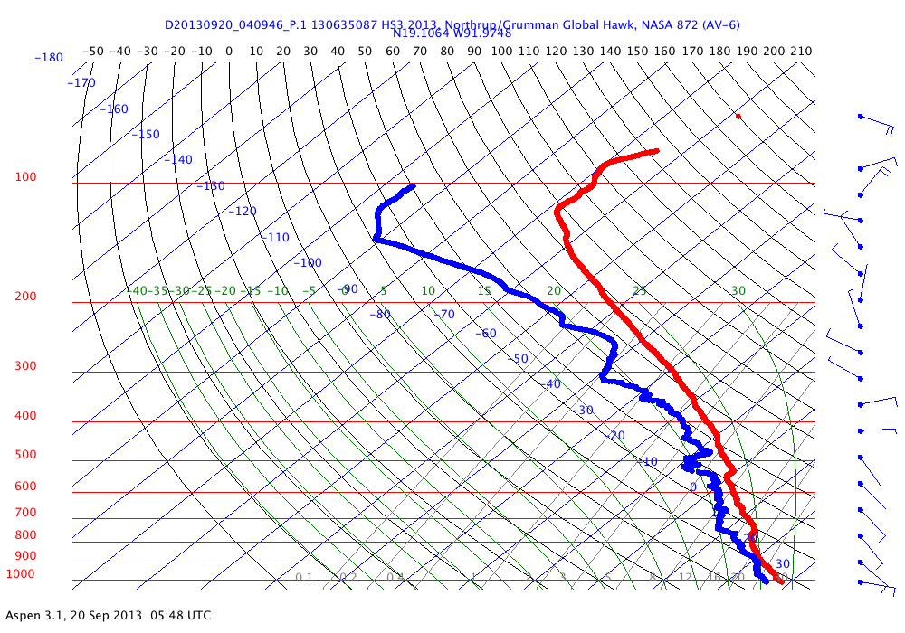
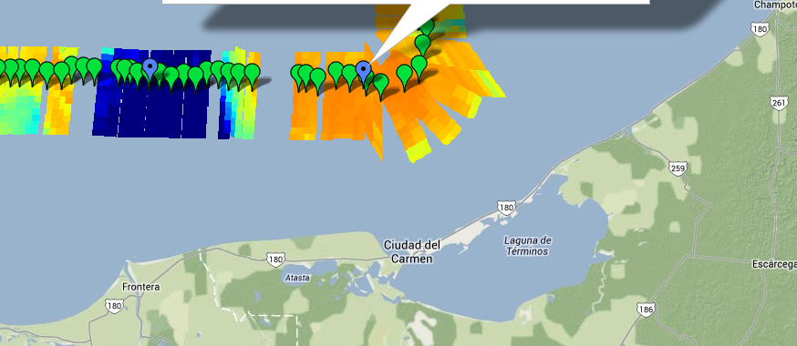
Figure 4. Comparison between S-HIS temperature and moisture structure (left) with the dropsonde profiles (right). This comparison is in the extreme SE corner of the flight pattern. Note that the water vapor around 700 mb is saturated in S-HIS profile but not in the AVAPS profile.

