S-HIS Flight Summary: 20-21 August 2013
Revision: 21 August 2013, R. Knuteson, University of Wisconsin-Madison, SSEC
Summary:
Nominal operation. No problems encountered. Real-time retrievals available on MTS.
Timeline (All times are UTC and approximate):
- 20130820T1237 SHIS power ON prior to takeoff
- 20130820T1242 Takeoff
- 20130820T2247 SHIS power OFF requested by PM inflight to diagnose AVAPS
- 20130820T2308 SHIS power ON
- 20130820T2320 SHIS detector at 78 K. Back to normal operation.
- 20130821T1208 Descent heaters ON
- 2013082110223 Instrument power OFF before descent
- 2013082110243 Instrument power ON
- 2013082110306 Instrument power OFF
- 2013082110347 Landing

S-HIS Quicklook BT Map for flight 20130820 at 11 microns (985-905 cm⁻¹)
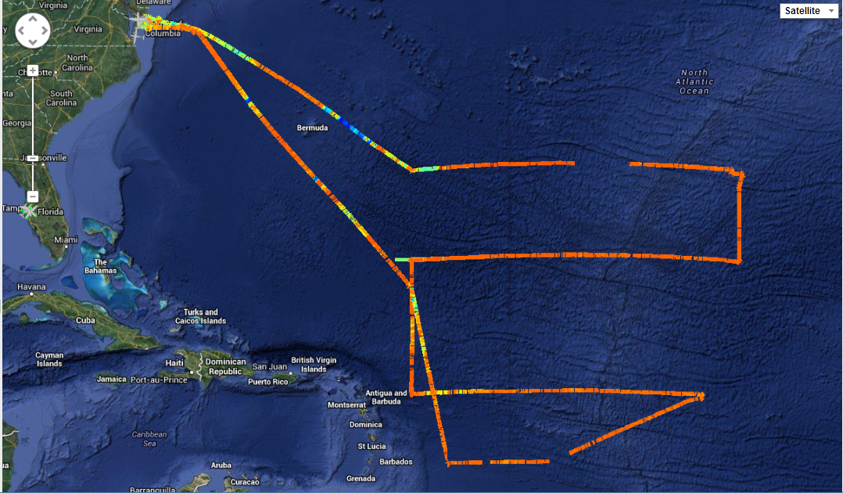

S-HIS Retrieval: SkewT Quicklook Example
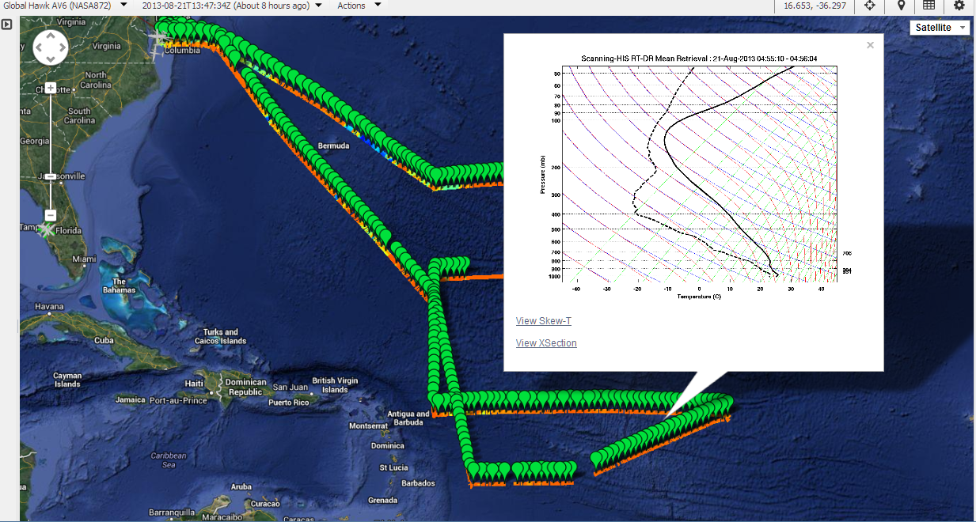
S-HIS Retrieval: RH x-section Quicklook Example: 3rd leg West to East into SAL at 17.4 North Latitude
